Chapter 14, Solution 42.

- This is a series RLC circuit.

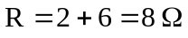, 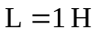, 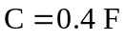

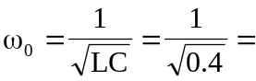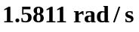

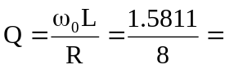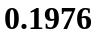

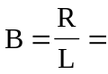

- This is a parallel RLC circuit.

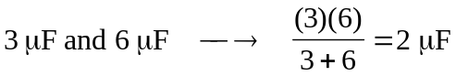
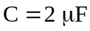, 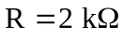, 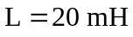

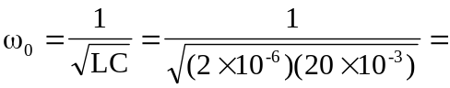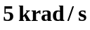

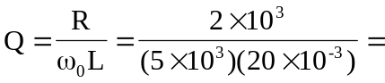

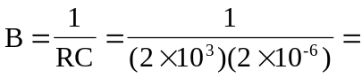 250 rad/s

